|  |
| --- |
| Sales  Report |

|  |
| --- |
| Amazon |

|  |  |
| --- | --- |
| KRITIKA SHARMA  PROJECT REPORT |  |



Contents

* Introduction
* Methodology
* Key Findings
* Data Visualization
* Insights & recommendations
* conclusions

|  |
| --- |
| INTRODUCTION |

|  |  |  |
| --- | --- | --- |
| Summary Sales management has gained importance to meet increasing competition and the need for improved methods of distribution to reduce cost and to increase profits. Sales management today is the most important function in a commercial and business enterprise.  The analysis focuses on understanding sales trends, key metrics, and factors affecting sales performance using Amazon sales data. The dataset comprises information on regions, countries, item types, sales channels, order priorities, order dates, and ship dates. | | |
| person at a table writing in a notebook with people around | | |
| **Objectives:**   * Identify sales trends month-wise, year-wise, and yearly_month-wise. * Determine key metrics and factors influencing sales. * Visualize meaningful relationships between attributes to gain insights into sales performance. |  |  |

|  |
| --- |
| METHODOLOGY |

|  |  |
| --- | --- |
| **“People don’t just buy products today; they also buy visions of a better tomorrow.”** | person sitting at table working on laptop |
| * Data Cleaning: Remove duplicates, handle missing values, and format columns. * Exploratory Data Analysis (EDA): Analyze sales trends, distribution of sales across regions, and identify top-selling items. * Data Visualization: Create visualizations such as bar graphs, line charts, and scatter plots to represent sales data effectively. * Statistical Analysis: Use statistical techniques to identify correlations, outliers, and trends in the data. |

Sales Trends:

KEY FINDINGS

* Monthly: Identified peak sales months and seasonal variations.
* Yearly: Analyzed sales performance over years to identify growth trends.
* Yearly-month-wise: Examined sales patterns for specific months across different years.

Key Metrics and Factors:

* Top-selling Items: Identified best-selling products and their contribution to overall sales.
* Sales Channels: Evaluated the effectiveness of different sales channels in generating revenue.
* Regions/Countries: Analyzed sales performance across different regions and countries.
* Order Priorities: Investigated the impact of order priorities on sales volume.
* Bar Charts: Used to compare sales across regions, countries, and sales channels.

DATA VISUALIZATION

* Line Charts: Depicted sales trends over time (months, years).
* Scatter Plots: Explored relationships between sales volume and other variables.
* Heatmaps to show relationships between various variables
* Stacked column charts to depict the yearly as well as monthly profit by Regions
* Monthly profit trends with the help of line chart
* Scatter plot to compare the mode i.e online or offline.

The charts ara as follows:

* 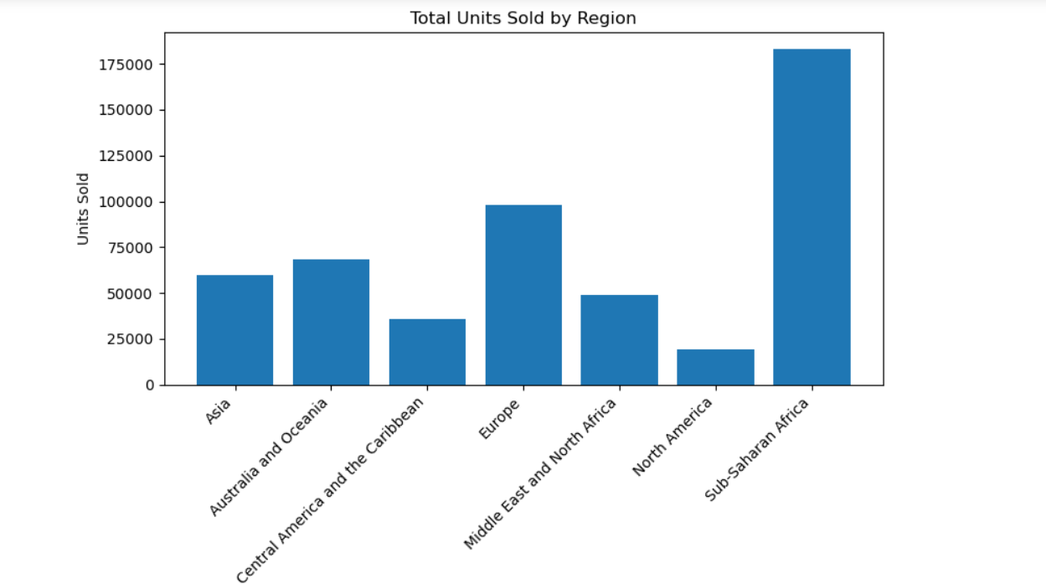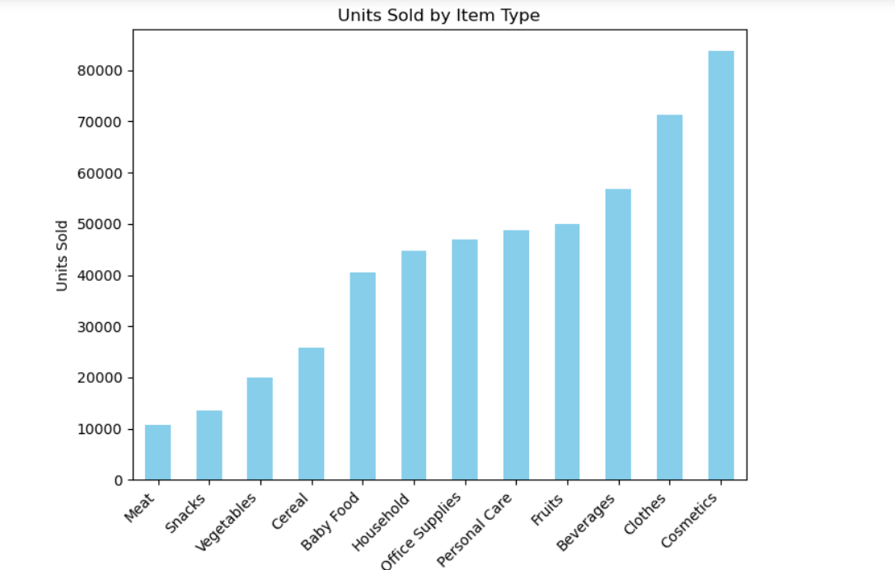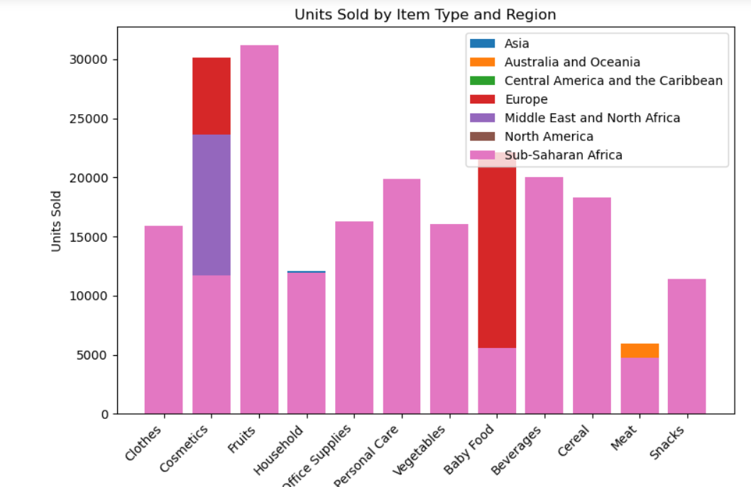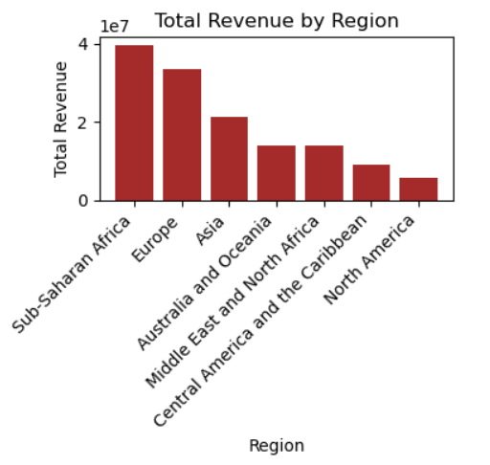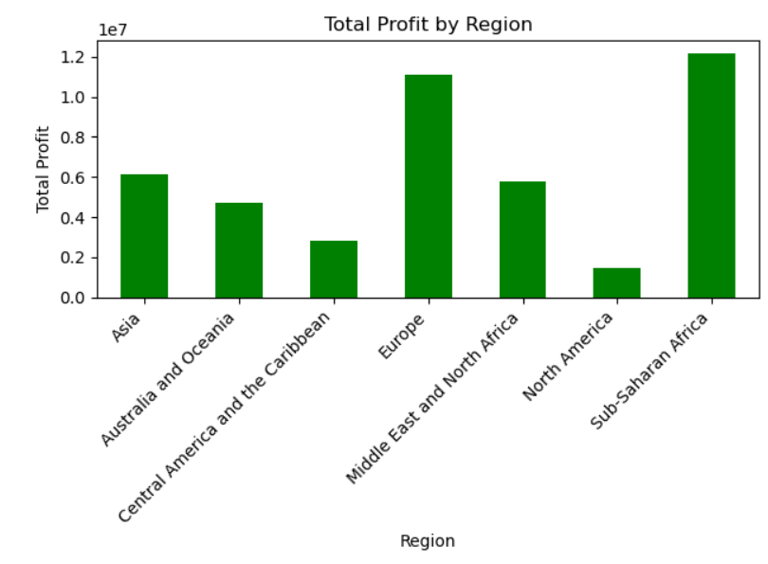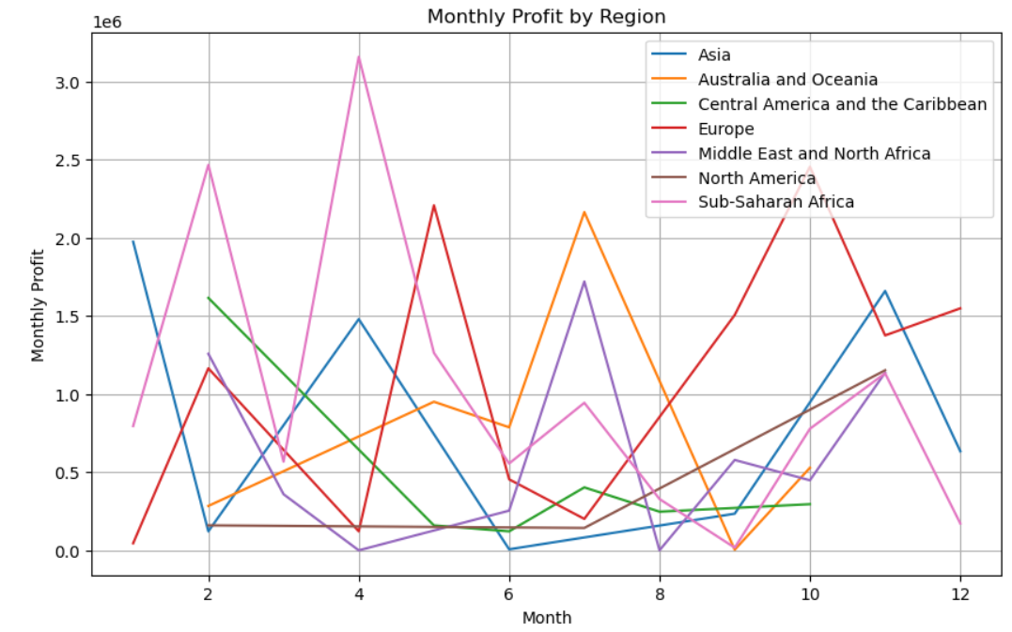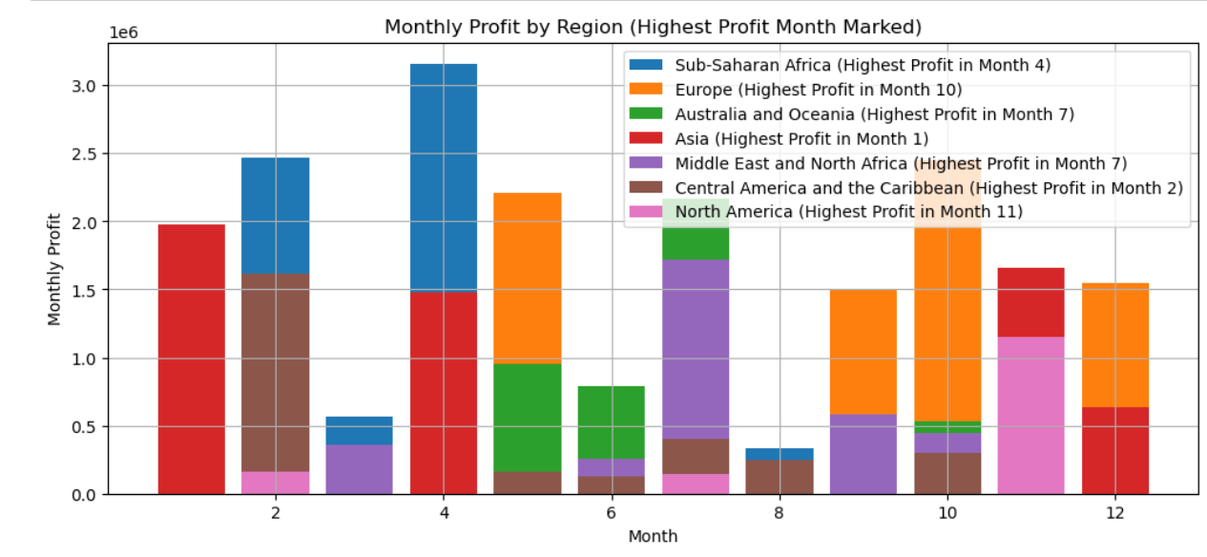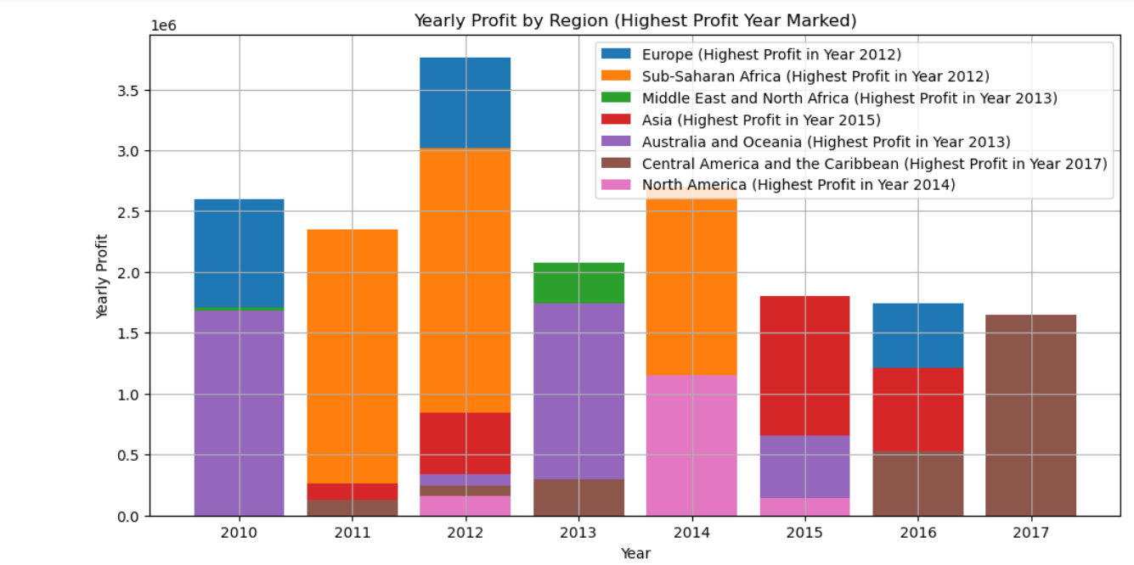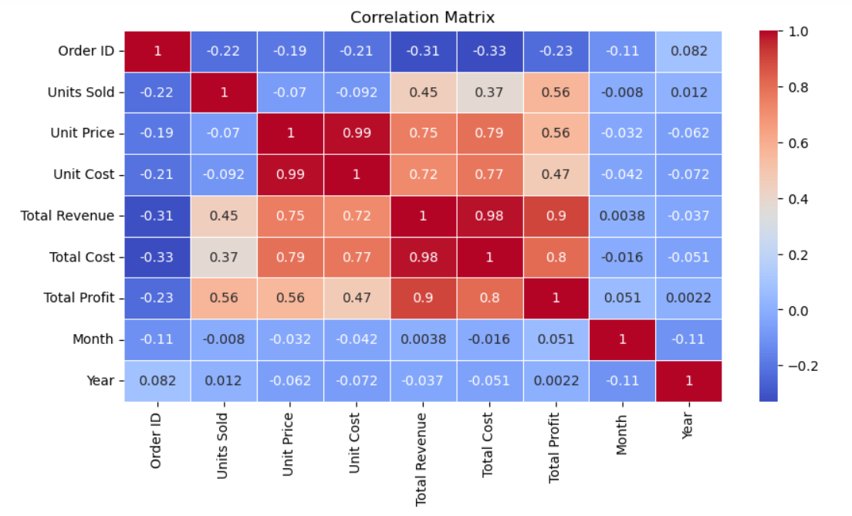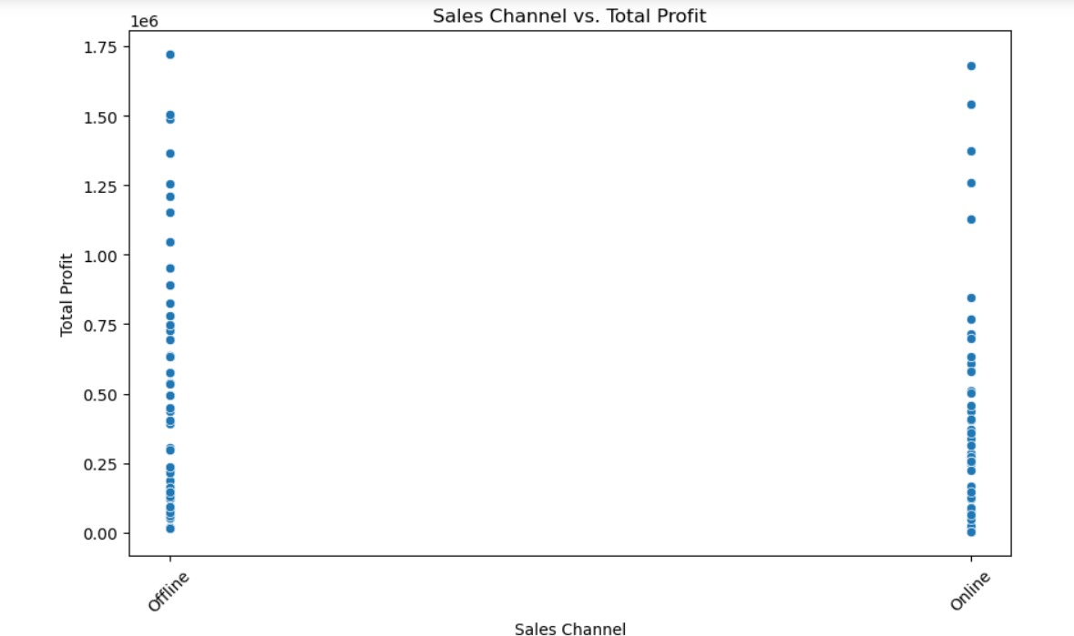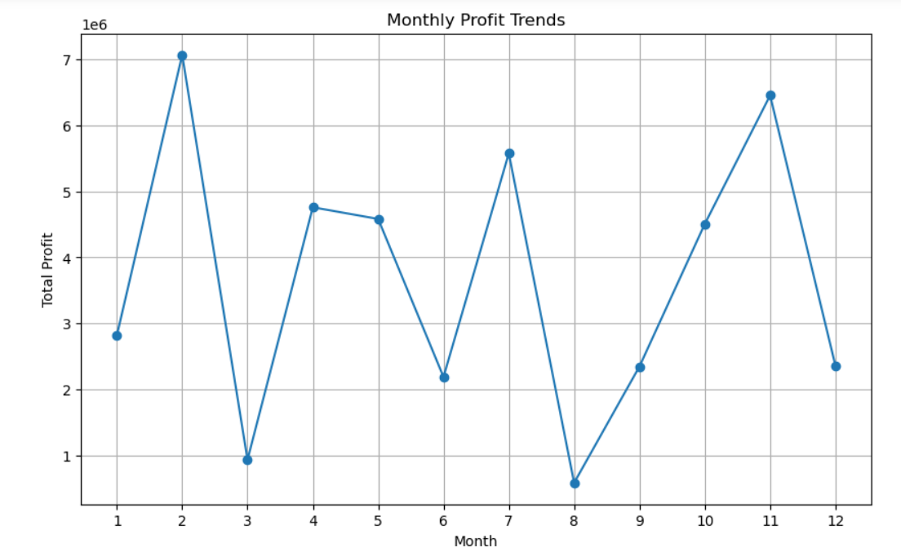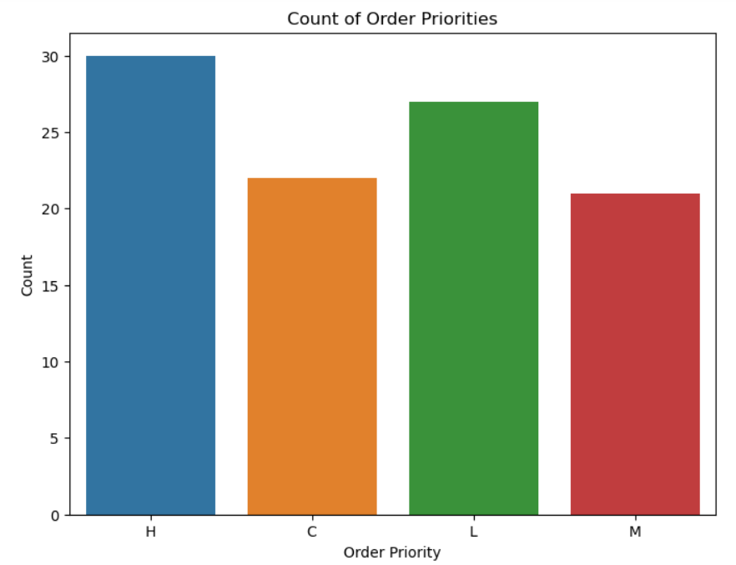

Insights and Recommendations:

* Seasonal Promotions: Suggested targeted promotions during peak sales months.
* Channel Optimization: Recommended strategies to improve sales through high-performing channels.
* Regional Focus: Identified regions with growth potential for targeted marketing efforts.
* Inventory Management: Proposed inventory adjustments based on sales trends to avoid stockouts or overstocking.

CONCLUSION

The analysis provided valuable insights into Amazon sales performance, highlighting sales trends, key metrics, and actionable recommendations for optimizing sales strategies.

Mean Squared Error: 15118181009.87363

R-squared Score: 0.9095678745429016